**CS 457 Project #4 – The Magic Lens**

**By**: Rick Menzel  **Email**: [menzelr@oregonstate.edu](mailto:menzelr@oregonstate.edu)

**Screenshot(s)**:

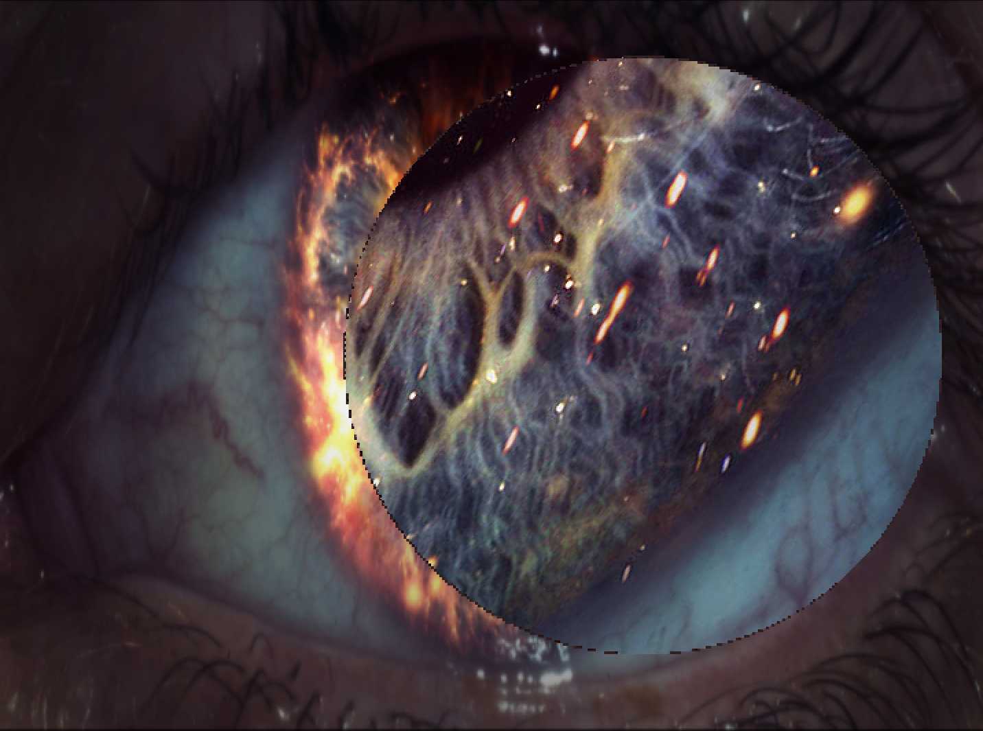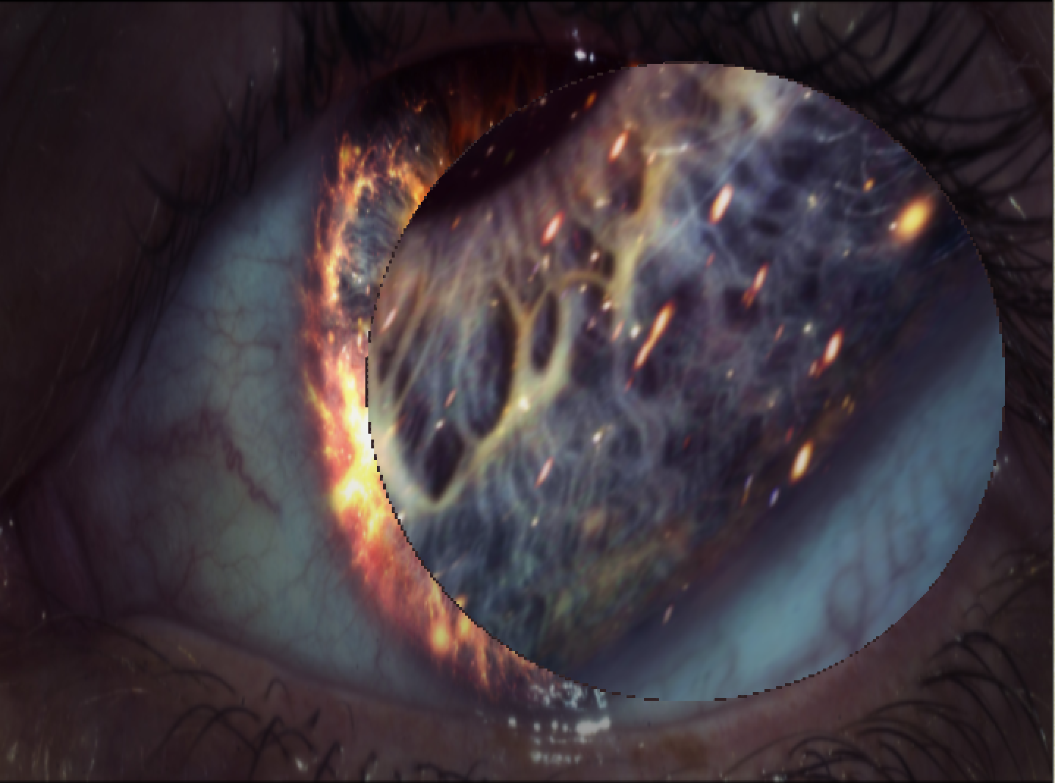

Fig 1. Lens in Action; Different Sharpness for Comparison

**Link**:

<https://media.oregonstate.edu/media/t/0_vaw2kjeb>